Organic Chemistry – Notes

Combustion reactions:
- CO₂ is always a gas.
- O₂ is always a gas.
- H₂O is always a gas.

Substitution reactions:
- H[halogen] is always a gas.
- [Halogen] solution is always aqueous.

For hydrocarbons of similar size/chain length, the melting point and boiling point depends on how close the molecules can get to each other.
- The closer the molecules are, the greater the intermolecular forces and the greater the melting point and boiling point because more energy is required to overcome these forces.
- How close the molecules can get to each other is dependent on their stereochemistry (shape).
- Benzenes can get closer than alkanes which can get closer than alkenes.
- Therefore, melting point and boiling point for similar size/chain length is: alkene<alkane<benzene.

For hydrocarbons of different size, the longer the chain (more atoms in molecule), the greater the intermolecular forces.
- This means that the larger the molecule, the greater the melting point and boiling point.
- E.g., octane has a higher melting point and boiling point than methane.

In straight-chain hydrocarbons, the carbon atoms are bonded into a single chain of consecutive carbon atoms. Terminal carbon atoms are bonded to 3 other hydrogen atoms and all others are bonded to 2. In a branched hydrocarbon structure, some carbon atoms may be bonded to 3 or 4 carbon atoms. This means there will be side chains to the main chain of hydrocarbons.

Alkanes are saturated hydrocarbons – their molecules don’t contain double bonds. Their general formula is C_{n}H_{2n+2}. Alkenes are unsaturated hydrocarbons – their molecules contain one double bond. Their general formula is C_{n}H_{2n}. Thus, an alkene molecule has 2 less hydrogen molecules than a corresponding alkane with the same number of carbon atoms.

The structural formula of cyclopentane shows that each carbon atom is bonded to 2 other carbon atoms and 2 hydrogen atoms. This is also the case for pentane except that the terminal carbon atoms are bonded to one other carbon atom and 3 hydrogen atoms.

Both cyclohexane and benzene consist of a cyclic ring of 6 carbon atoms. In cyclohexane, each carbon atom is bonded to 2 hydrogen atoms and has a single bond to each adjacent carbon atom. In contrast, each carbon atom in benzene is bonded to one hydrogen atom and the bonds to adjacent carbon atoms are intermediate in nature between a single bond and a double bond.

The octane rating is higher for molecules with branching. Thus, for structural isomers, the octane rating is higher as the molecular formula branching increases.
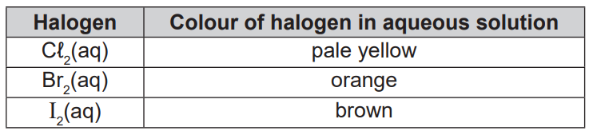
Addition reaction = Rapid change from [colour of halogen in aqueous solution] to colourless.
Substitution reaction = Slow change from [colour of halogen in aqueous solution] to colourless.

